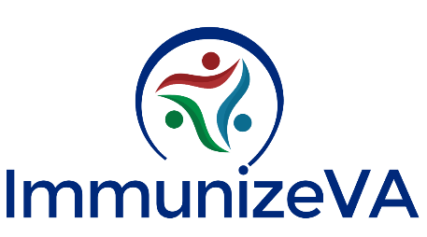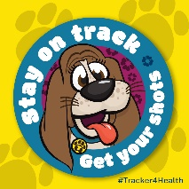
To celebrate National Immunization Awareness Month this August, ImmunizeVA has created the following Flat Stanley-inspired activity for you and/or your little ones to complete at home:
- Print and cut out Flat Tracker
  - B+W version if you’d like to color
- Document her adventures (pictures are encouraged!)
  - Where in Virginia did Tracker visit now that she is vaccinated?
  - What activities did she do while she was there?
- Email immunizeva@institutephi.org or tag @ImmunizeVA on social media with her location, any pictures, and hashtags #FlatTracker #NIAM
  - Top entries will be selected for age groups 0-4, 5-8, and 9+ and fun prizes will be mailed!
Ideas
- Explore Virginia geography and culture of the places that Tracker visits

- Take Tracker with you to your Vaccine Appointment or Routine Check-Up

- Tell us why vaccines are important to you

