Month-long

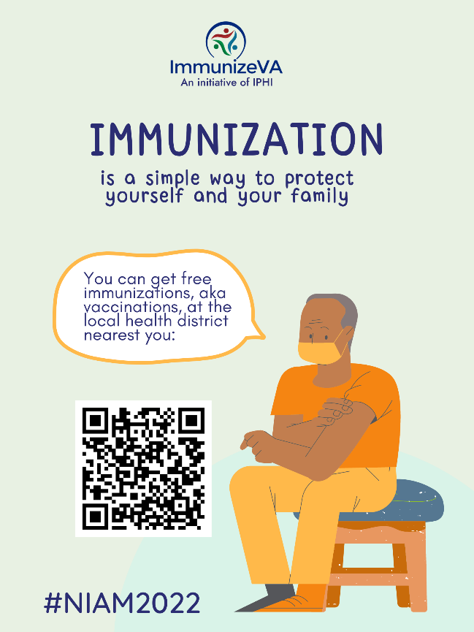
Let’s give it up for our Local Health Districts! The past two years, these public health powerhouses have kept our communities well taken care of and vaccinated. Give your LHD a shoutout by tagging them in this post! Or if you don’t know your own LHD, use our QR code to find out #NIAM2022

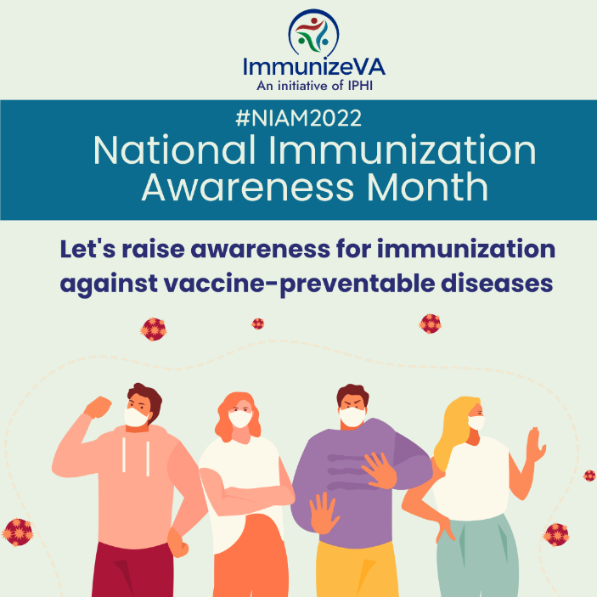
Caption: ‘Raising awareness’ can start to feel like a trite phrase; there are so many things to be aware of these days. But what raising awareness for vaccines really means is having conversations with loved ones, neighbors, even strangers, letting them know how far we’ve fallen behind on routine vaccinations; sharing resources; letting the stats speak for themselves #NIAM2022

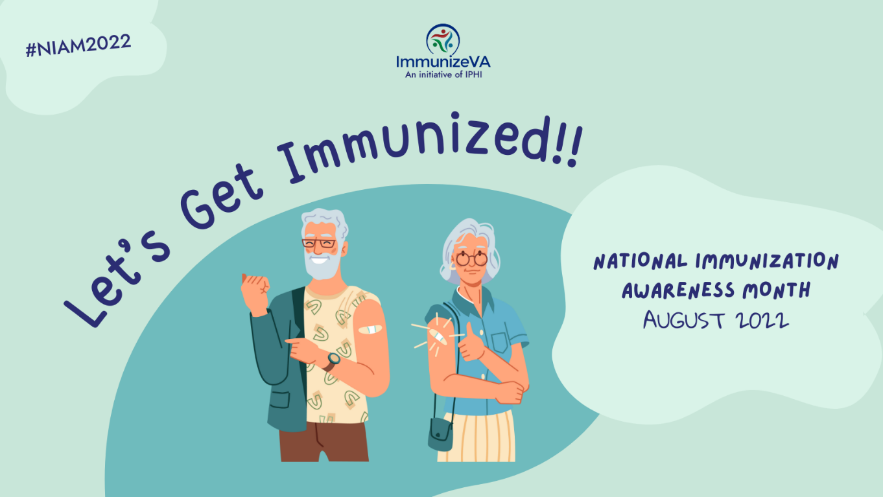
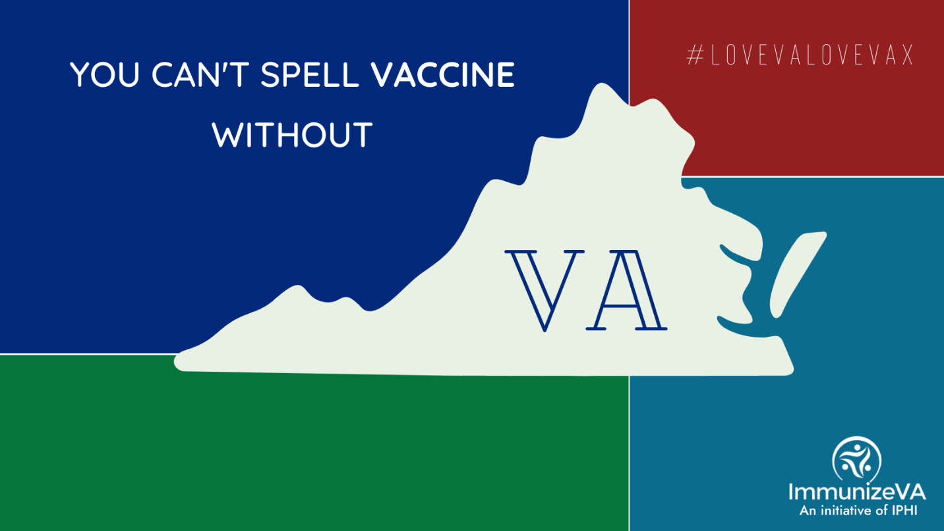
Virginians get vaccinated! #lovevalovevax #NIAM2022

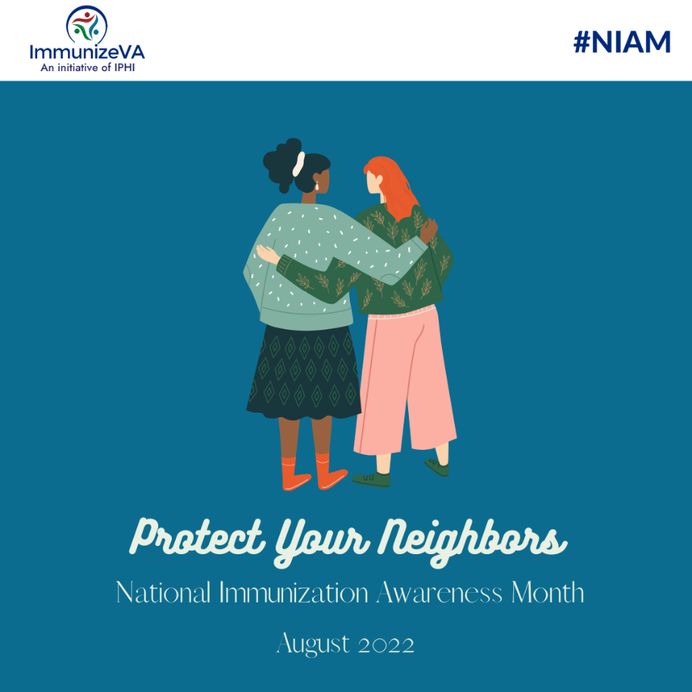
Whether it be your neighbor, your best friend, your family, or your school bus driver, vaccination and community immunity boil down to caring for and protecting those around you #NIAM2022

Week 1 (Aug 1-5)
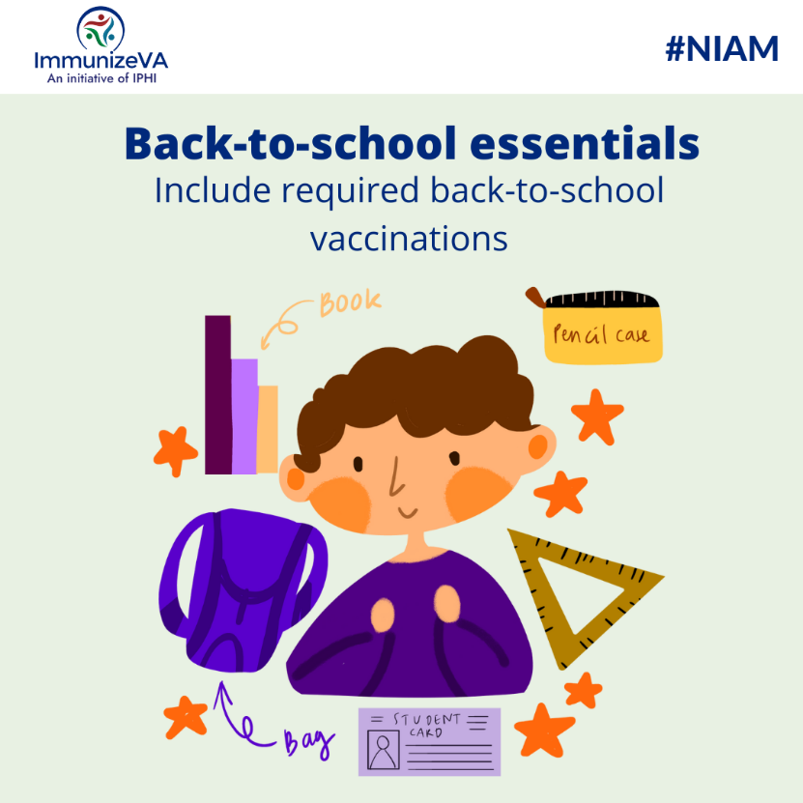
Wondering which vaccines your children need before they head back to school in a few weeks? Find out here: https://www.vdh.virginia.gov/immunization/requirements/ #NIAM2022
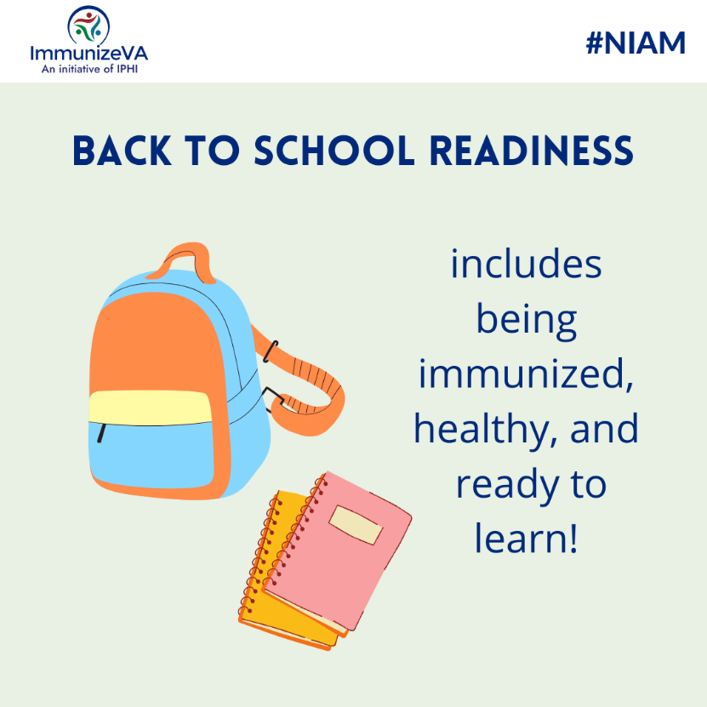
Backpack? Check. Notebooks? Check. Vaccines? Make sure to get yours early in August, before the back-to-school rush: https://www.vdh.virginia.gov/immunization/requirements/ #NIAM2022

Week 2 (Aug 8-12)
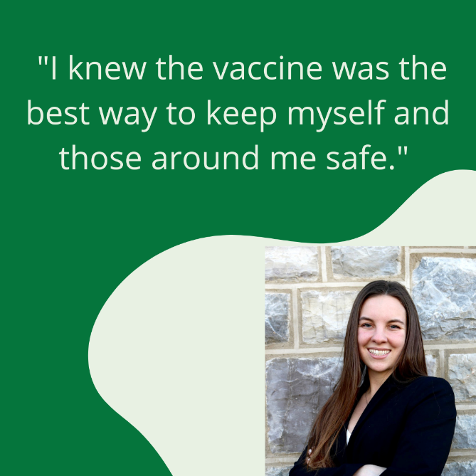
Covid-19 may be the most talked about vaccine right now, but there are many immunizations that are important for college students. I made sure to get all the recommended vaccines especially the meningitis vaccine before living on campus. The close contact with many other students increases the risk of contracting meningitis especially when living in dorms, and I knew the vaccine was the best way to keep myself and those around me safe. Before school starts make sure you’re up to date on all your vaccines to keep yourself healthy!
~Olivia, ImmunizeVA Intern #NIAM2022

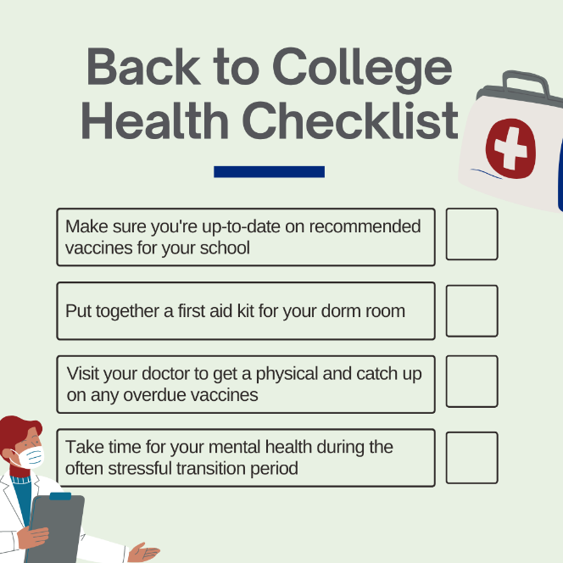
Before you head off to school this fall make sure you are up to date on all the vaccines recommended and required for your university. Close contact among peers can increase the risk of exposure to a variety of diseases such as MeningitisB, which is why it’s extra important you keep up to date with your doctor’s visits! #NIAM2022

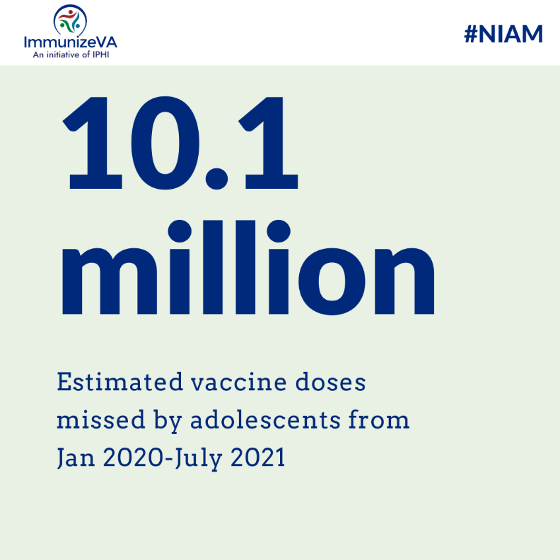
Covid-19 caused teens to miss out on numerous formative experiences- homecomings, proms, graduations. But the pandemic also caused millions of teens to miss their needed routine vaccines. Let’s get back on track, to ensure that there are no more disruptions to these young people’s lives caused by vaccine-preventable disease #NIAM2022

Week 3 (Aug 15-19)
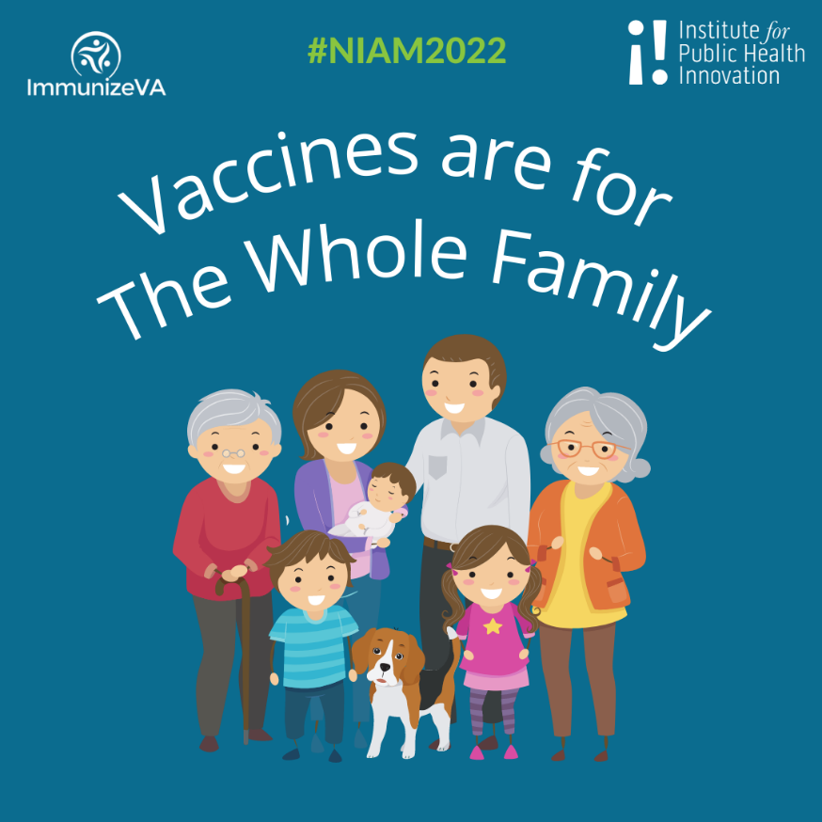
This fall keep the whole family (including Tracker!) safe by staying up to date on childhood and adult vaccinations. Visit the CDC at https://www.cdc.gov/vaccines/hcp/acip-recs/index.html to see the current vaccination recommendations, many of which effect our 65+ community #NIAM2022

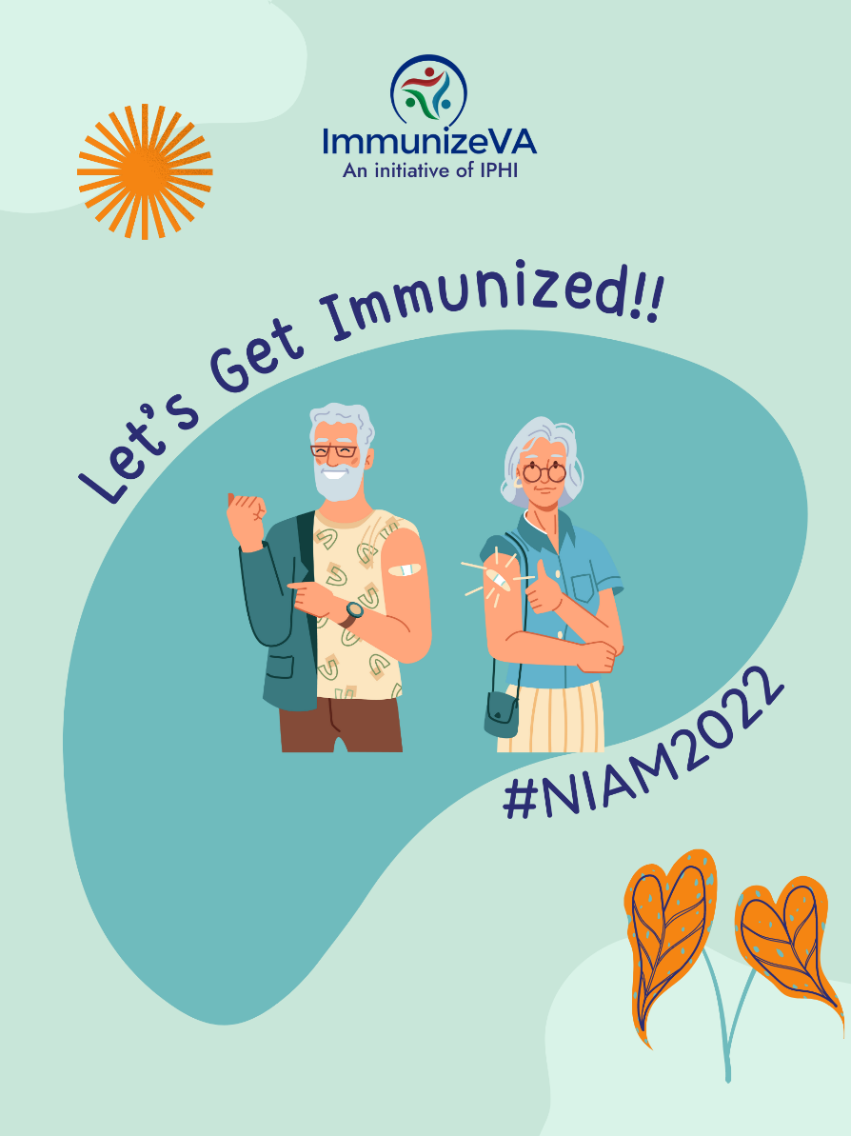
Getting older can bring with it a lot of big changes. One thing that doesn’t have to change is keeping yourself protected from vaccine-preventable disease #NIAM2022

Week 4 (Aug 22-26)
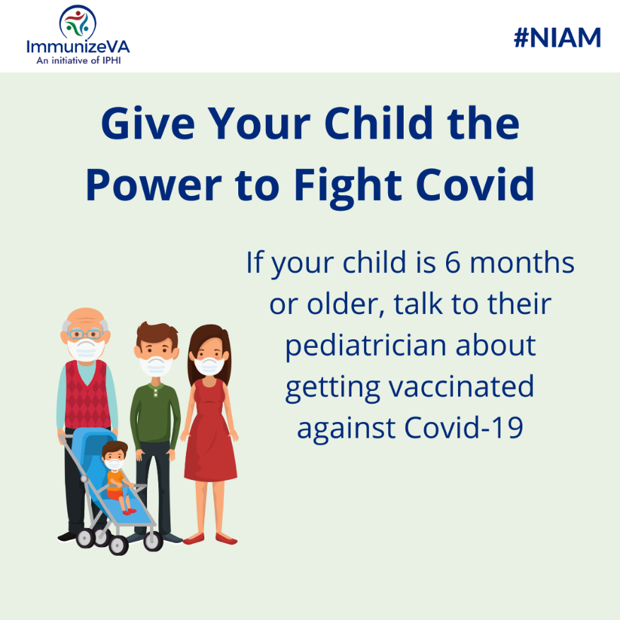
Protect the ones you love: find out where you can get your child vaccinated against COVID www.vdh.virginia.gov/covid-19-vaccine/covid-19-vaccines-for-children-and-teens/ #NIAM2022

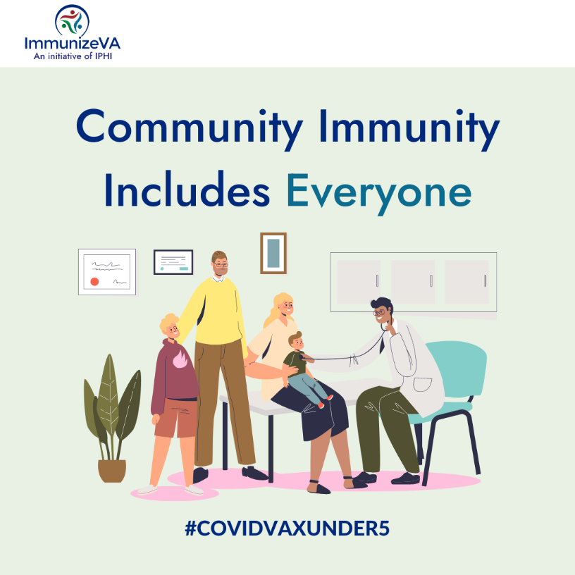
“We often vaccinate to protect those who cannot protect themselves. We should want as many people, including children, to get immunized as soon as possible to make all people safer.” – Dr. Aaron Carroll, NYT Opinion

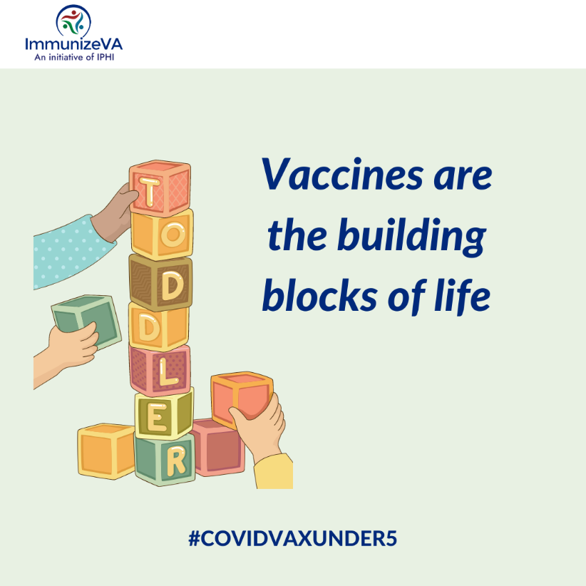
Learn more about the importance of covid vaccination for our young ones: https://www.healthychildren.org/English/tips-tools/ask-the-pediatrician/Pages/what-should-parents-know-about-the-covid-vaccine-for-kids-under-5.aspx

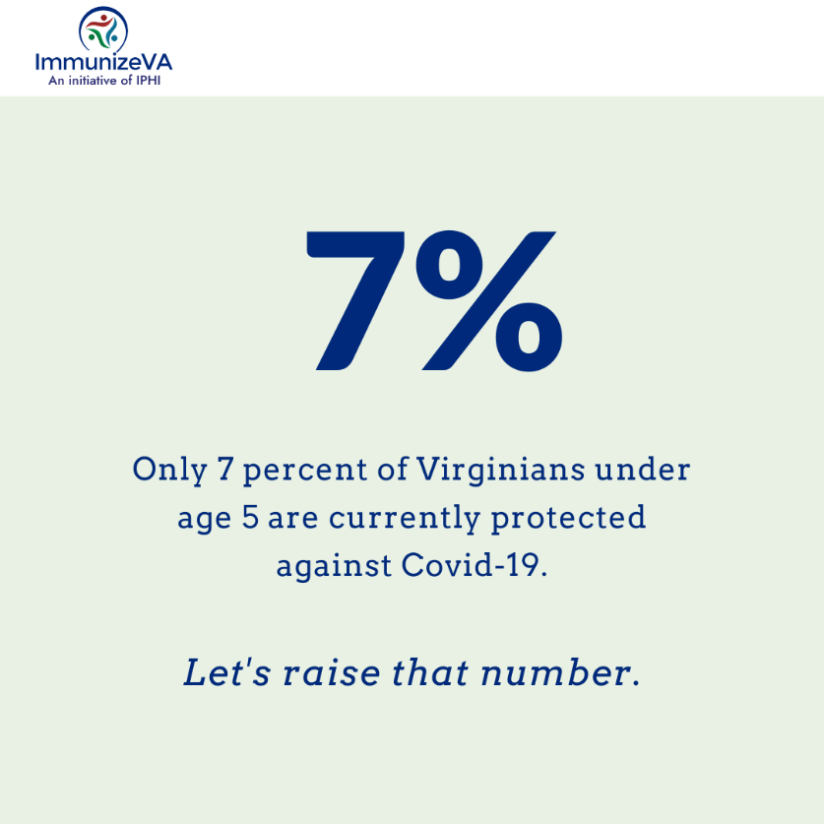
https://www.vdh.virginia.gov/coronavirus/see-the-numbers/covid-19-in-virginia/covid-19-vaccine-summary/covid-19-vaccine-demographics/

Week 5 (Aug 29-31)
The CDC recommends that everyone gets vaccinated against #flu by the end of October. Start preparing for #backtoschool by scheduling your child's well-visit appointment to get them protected against flu! #NIAM2022

